Daschbach Dentistry

Formal business and technical requirements and specifications document

Contents

Index 1

Contact 1

Client 1

Developer 1

Website 1

Overview 1

Summary 1

Service(s) Requested 2

Page By Page Review of Demo Website 2

General 2

Key Terms 2

Navigation Bar 2

Responsive Viewing 3

Summary of Links Provided 3

Footer 4

Landing Page 4

Business Justification 6

Technical Detail 6

Services 6

Business Justification 8

Technical Detail 8

Meet the Doctors 9

Desktop View 9

Responsive View 9

Business Justification 10

Technical Detail 10

Mission Statement 10

Business Justification 11

Technical Detail 11

New Patient Forms 11

Business Justification 11

Technical Detail 11

Photo Gallery 11

Business Justification 12

Technical Detail 12

Desktop View 12

Responsive View 13

Our Staff 13

Business Justification 14

Technical Detail 14

Desktop View 14

Responsive View 15

Contact 15

Business Justification 15

Technical Detail 15

Desktop View 16

Responsive View 17

Careers 17

Business Justification 17

Reporting Issues 18

Load Times 18

# Contact

## Client

|  |  |  |
| --- | --- | --- |
|  |  | Approved By |
| Company Name | Daschbach Dentistry |  |
| Locally Known As |  |  |
| Company Address |  |  |
| Name of Main Point of Contact |  |  |
| Company Phone Contact for Public Use |  |  |
| Company Phone Contact for Communication Between Ryan Piveteau and Client |  |  |
| Company Email Contact  for Communication Between Ryan Piveteau and Client |  |  |

## Developer

|  |  |
| --- | --- |
| Developer Name | Ryan Piveteau |
| Living Address | 141 Levering Street Philadelphia PA 19127 |
| Phone Contact for Business Communication | 610 906 4133 |
| Email Contact for Business Communication | ryanpiveteau@gmail.com |
| Personal Website | ryanpiv.github.io/welcome |

## Website

|  |  |
| --- | --- |
| Demo website URL | das |
|  |  |
|  |  |

# Overview

## Summary

The current website at the URL (<http://www.daschbachdentistry.com/> ) is in need of reconstruction. The intention is to remove the current files on the web server and replace them with new ones. Old files will be kept as backup. All current domain name information will be kept the same, including domain name and top level domain information. Current hosting will be considered in the move to the new website.

The website development will be approached using flat design standards from a mobile first perspective. This ensures the website to function properly on all devices while keeping a consistent format of color and schema of object orientation across all platforms of devices attempting to view the website.

## Service(s) Requested

* Advice on website design
* Advice on technologies needed for redesign
* Advice on modern design standards
* Advice on server ownership
* Advice on domain ownership
* Advice on company logo
* Demonstration of website design vision
* New design of website
* New development of website
* New provision of formal company email addresses using the @daschbachdentistry.com predicate

# Page By Page Review of Demo Website

The demonstration website can be accessed by the provided URL:

* http://daschbachdentistry.gear.host/

All features shown in this website are under review and should not be considered as final.

## General

Information shown in this section is applicable to all parts of the website. It may be accessed during any part of the navigation process.

### Key Terms

This section is provided to serve as a general use to whomever may be reading and require additional information about the terms used. It is important to briefly read this section before continuing on to prohibit confusion. If terms are not understood, this section should be referenced first to serve as a FAQ.

**Responsiveness**: The website, or specific features of the website, may be referred to as responsive. This means the specific being referenced has the ability to change depending on the screen size of the device accessing it.

**Navigation (nav) Bar:** The navigation (or nav) bar allows for users to access different parts of the website. It can always be seen at the top of any web page.

## Navigation Bar

The navigation (or nav) bar allows for users to access different parts of the website. It will always be present at the top of the page. This bar is programmed to be responsive to the device accessing it.

### Responsive Viewing

The navigation bar will appear as follows in browsers with a screen width greater than 1280 pixel density:



For devices with screen widths smaller than 1280 pixels, the navigation bar will appear as follows:



The icons have shifted to be included in the ‘hamburger’ icon to the right. The symbol is described as a hamburger by the web design industry and should be referred to as such. It is described this way as that is how it appears.

The hamburger icon expands the navigation list when clicked. A click action is the same as a touch on touchscreen devices and works in the same manner. When clicked or touched, the list appears as follows:

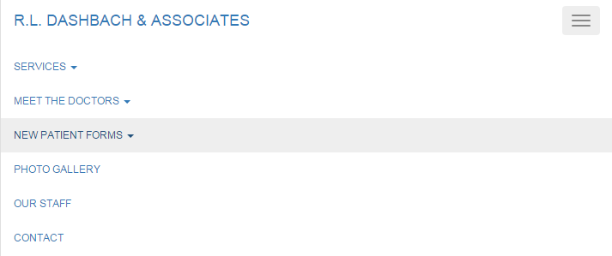

Highlighting allows for users to find which element they have scrolled over to ease of access. This is also shown in the screenshot above.

Lists may be further expanded when expansion is available. Expansion is dedicated by the upside down caret symbol.

### Summary of Links Provided

A list containing the text in the nav bar is shown below, along with its associated URLs. The associated URLS depict where the user will move to on the website when a link is clicked.

* R.L. Daschbach & Associates (http://daschbachdentistry.gear.host/index.php)
* Services
  + Currently, all services links in this list point to the URL below for ‘Services’
    - http://daschbachdentistry.gear.host/services.php
  + View All Services
  + Periodontal Services
  + Restorative Services
  + Prosthetic Services
  + Veneer & Cosmetic Services
  + Dental Implant Therapy
  + Pediatrics and Prevention
  + Financial and Insurance
* Meet the Doctors
  + Meet the Doctors
    - http://daschbachdentistry.gear.host/meet_the_doctors.php
  + Mission Statement
    - http://daschbachdentistry.gear.host/mission_statement.php
* New Patient Forms
  + The following four links do not move a user. Instead, they show a pop-up containing the associated .PDF document.
  + Hippa Form One
  + Hippa Form Two
  + Medical History Form
  + Surgical Form
* Photo Gallery
  + http://daschbachdentistry.gear.host/photo_gallery.php
* Out Staff
  + http://daschbachdentistry.gear.host/our_staff.php
* Contact
  + http://daschbachdentistry.gear.host/contact.php
* Careers
  + **( NOT YET IMPLEMENTED IN DEMO )**
  + Intended URL: http://daschbachdentistry.gear.host/careers.php
* Admin Console
  + **( NOT YET IMPLEMENTED IN DEMO )**
  + Intended URL: <http://daschbachdentistry.gear.host/admin.php>

## Footer

A footer is always present at the bottom of the page. The footer is responsive and will adapt to the browser’s width.



## Landing Page

* http://daschbachdentistry.gear.host/index.php
* http://daschbachdentistry.gear.host

Upon navigating to the demo URL, users are greeted by the landing page. This page may be accessed through the navigation bar link ‘R.L. Daschbach & Associates.’

### Desktop View

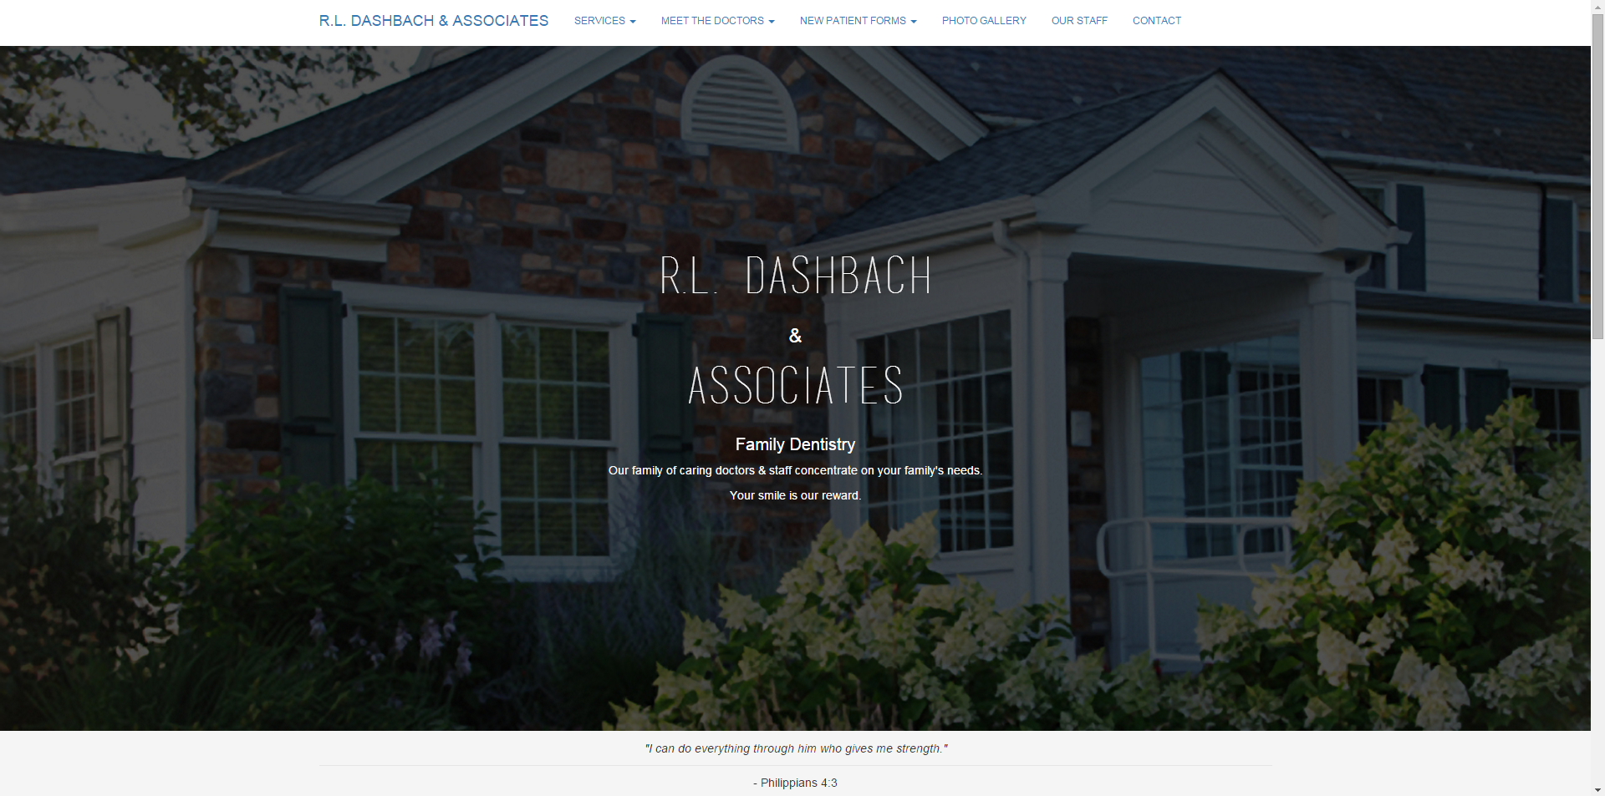

### Responsive View

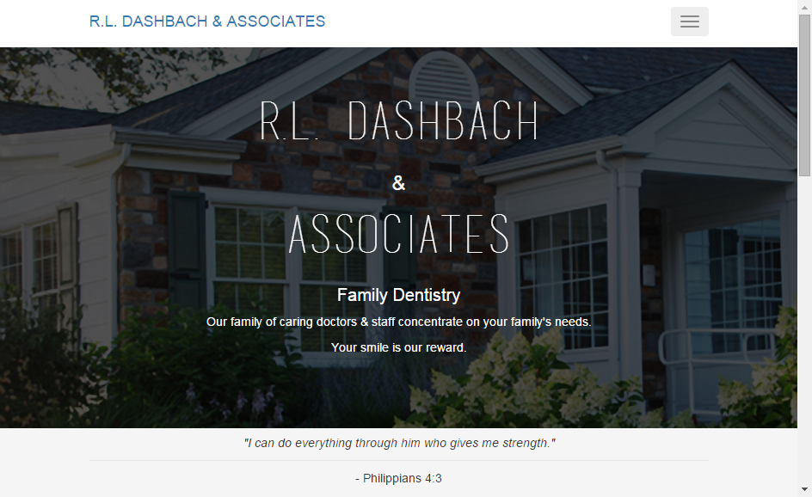

### Business Justification

The landing page is designed to provide users with an experience which is pleasing to the eye. This page must also represent the business well as it will serve as the first impression upon the user when first accessing the website.

This page may also contain a news feed of information to allow users to capture the newest improvements to the business in a manner which is important to them. It should be easily legible and compliant with most ADA standards due to the variety of patients accessing the website.

The news feed is currently composed of a slideshow and additional text. This is only shown for demo purposes and is not intended to be considered as final. The newsfeed is intended to be implemented after the website has launched for the sake of necessary requirements.

### Technical Detail

This page expands to one hundred percent of the browser’s width and height. It is responsive and will change to adapt to the browser’s current size.

The text in the middle of the page will always be centered.

## Services

The services page can be accessed by clicking the Services menu in the navigation bar and selecting any service. All links under the Services menu point to the URL listed below:

* http://daschbachdentistry.gear.host/services.php

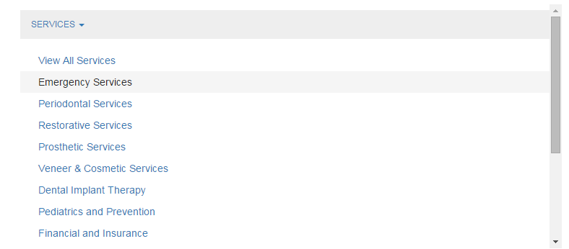

### Desktop View

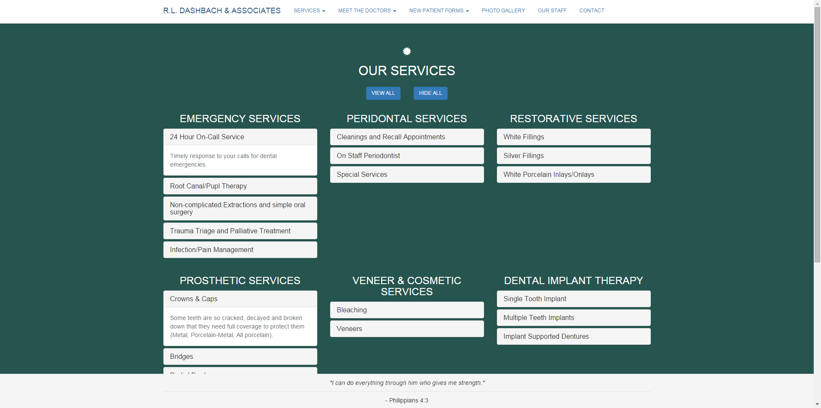

### Responsive View

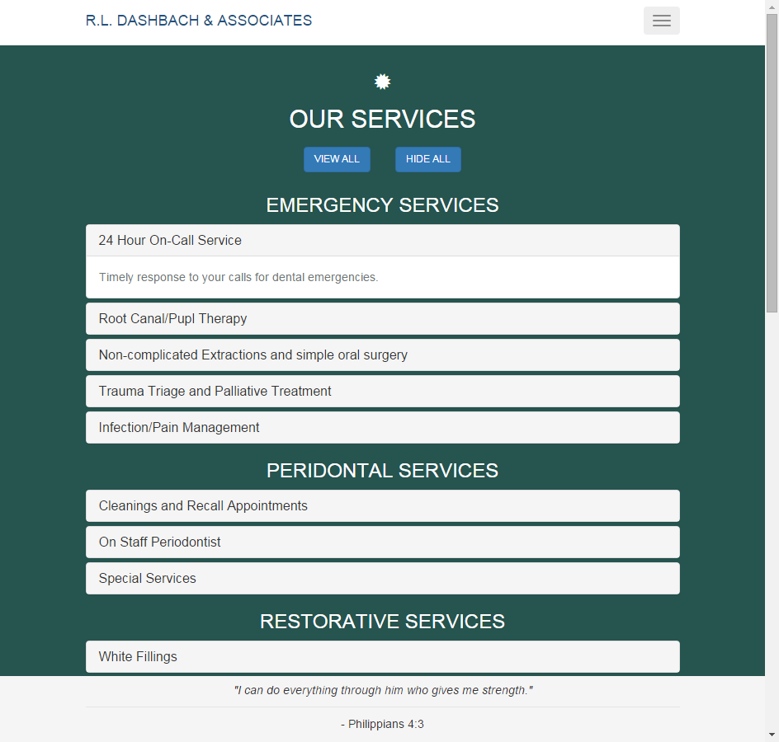

### Business Justification

The Services page provides a list of all available services to patients.

The services are organized through their respective sub sections. Each service should include short descriptions in the titles and details about the services in the description. Title and description information have yet to be clarified.

### Technical Detail

All services are shown in expandable lists. The ability to expand all lists or hide all lists exists via the use of two buttons with the text ‘View All’ and ‘Hide All’.

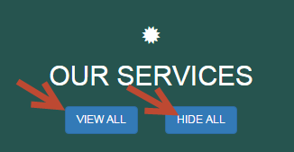

Services are expanded by clicking their titles, allow details to be shown.

When service sub sections are selected in the navigation bar, the user’s focus will be directed to the appropriate service on the web page. This is done by moving the scrolling position of the page to the service. This feature has not been implemented in the demo website.

## Meet the Doctors

Meet the Doctors can be accessed through the navigation bar item ‘Meet the Doctors’ and the sub-menu item ‘Meet the Doctors’.

* http://daschbachdentistry.gear.host/meet_the_doctors.php

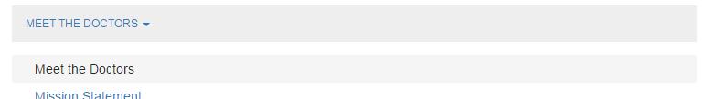

### Desktop View

**( NOT YET IMPLEMENTED )**

### Responsive View

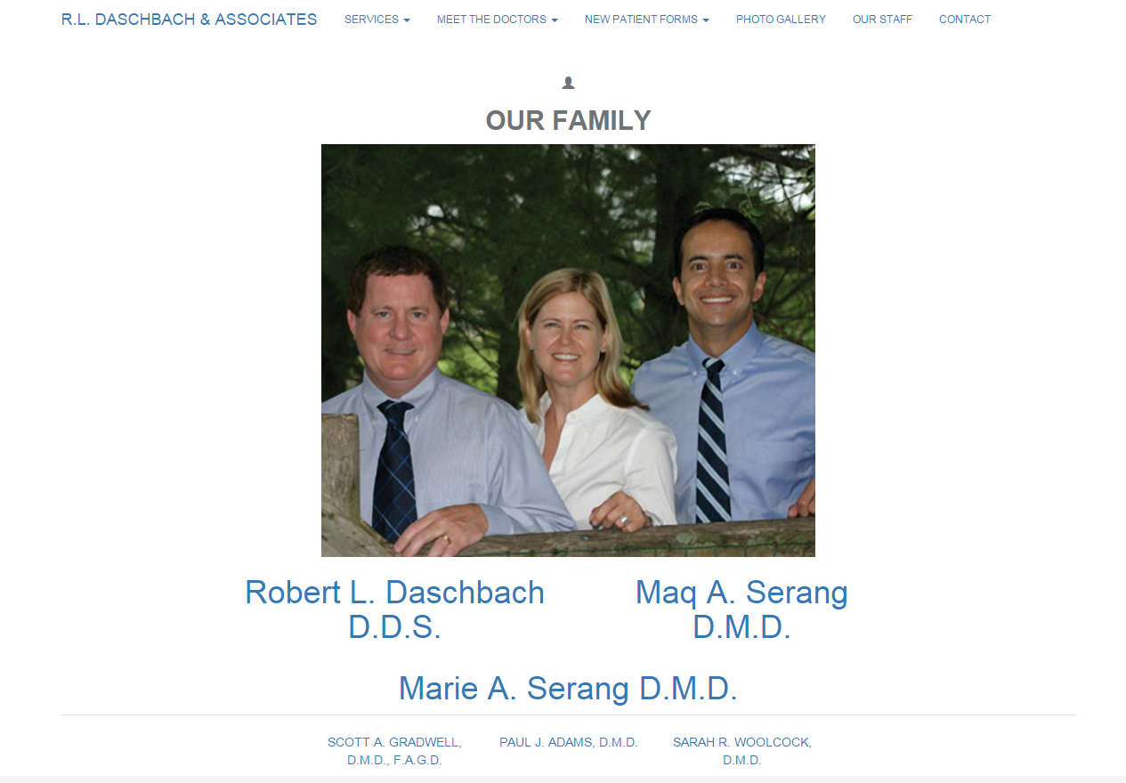

### Business Justification

Meet the Doctors allows us to put a face to a name. It brings personality to the website and gives information about the individuals who will be performing the work. It also helps to back up the personality of the business and the family-friendly feel of the office.

Doctor information will be displayed in a similar format for consistency. The most important aspect on this page is readability and access to doctor information. Pictures of each doctor will be shown in addition to a description.

Clickable links will be provided for navigation purposes.

Doctor information will be provided by the client in an external document.

### Technical Detail

## Mission Statement

The Mission Statement page can be accessed by clicking the Mission Statement menu in the navigation bar.

* <http://localhost:8069/Dashbach-Dentistry/mission_statement.php>

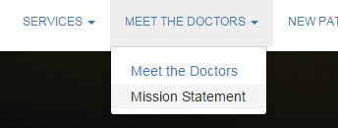

### Business Justification

### Technical Detail

The design of this page is currently not in accordance to the business requirements. As such, the current implementation should be disregarded for the moment.

## New Patient Forms

New Patient Forms do not have a page. They can be accessed at any time using the navigation bar menu titled ‘New Patient Forms’. When clicked, a pop-up will display and load the associated PDF documents.

* Hippa Form One
* Hippa Form Two
* Medical History Form
* Surgical Form

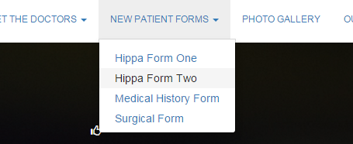

### Business Justification

### Technical Detail

## Photo Gallery

The Photo Gallery page can be accessed by clicking the ‘Photo Gallery’ link in the navigation bar.



* http://daschbachdentistry.gear.host/photo_gallery.php

### Business Justification

### Technical Detail

### Desktop View

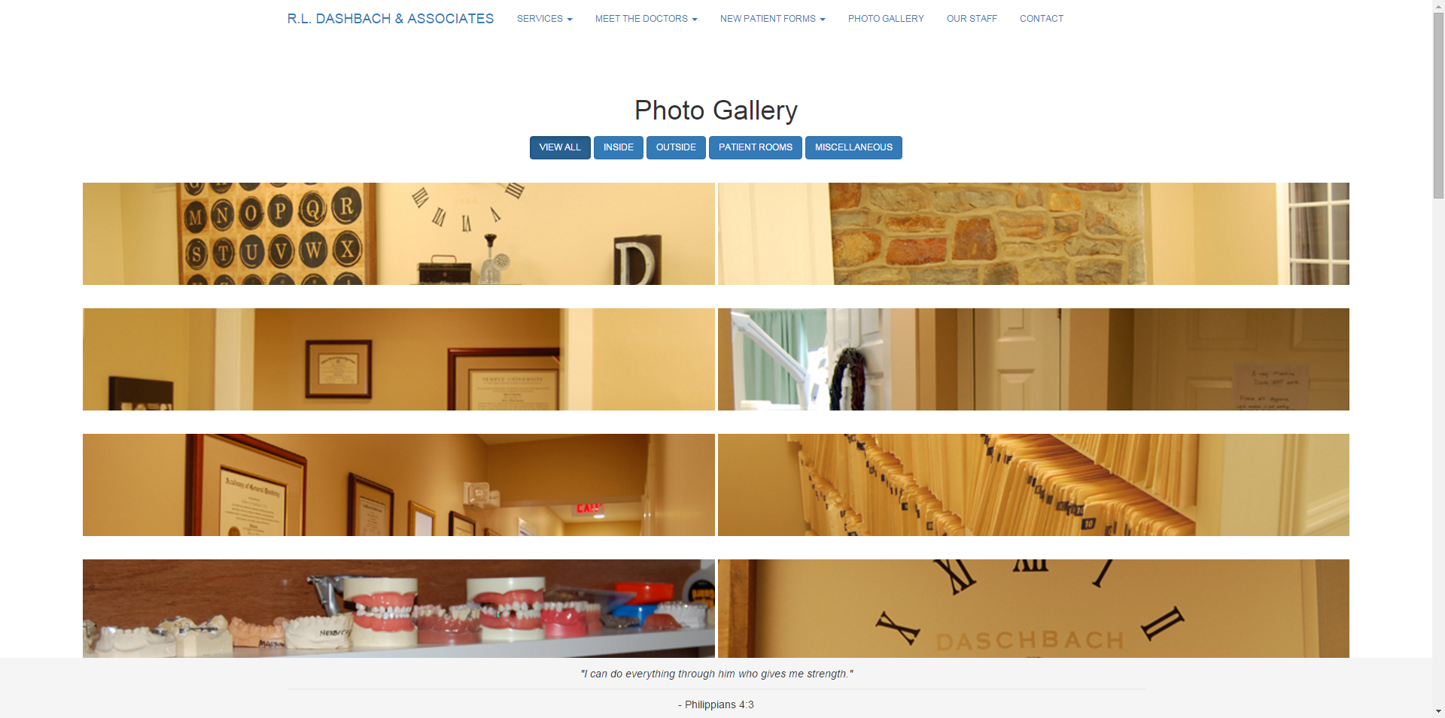

### Responsive View

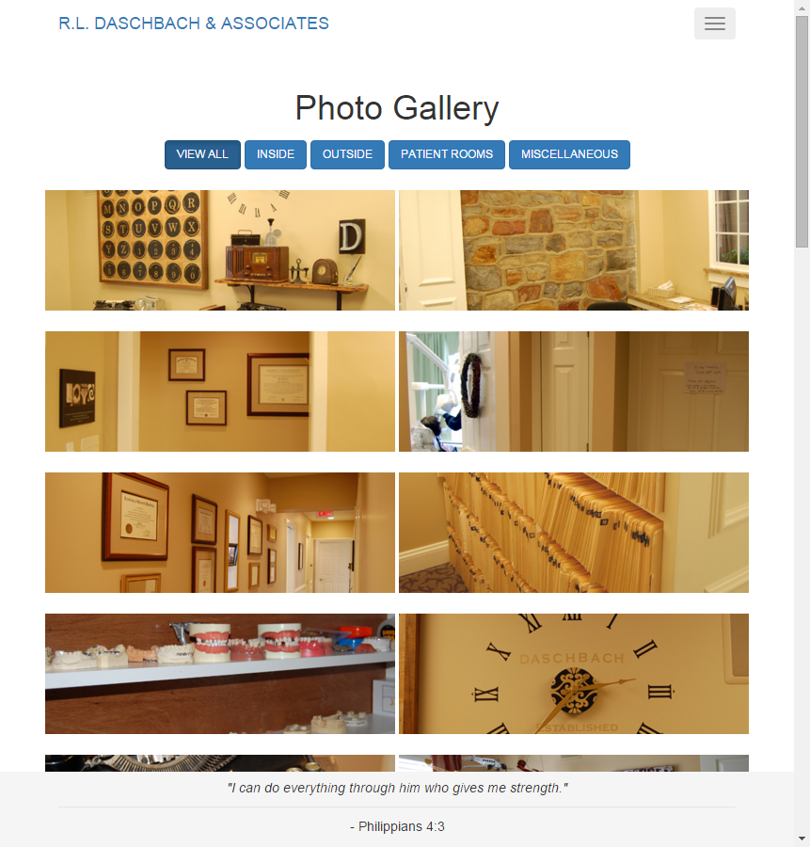

## Our Staff

The Our Staff page can be accessed by clicking the ‘Our Staff’ link in the navigation bar.



* http://daschbachdentistry.gear.host/our_staff.php

### Business Justification

### Technical Detail

### Desktop View

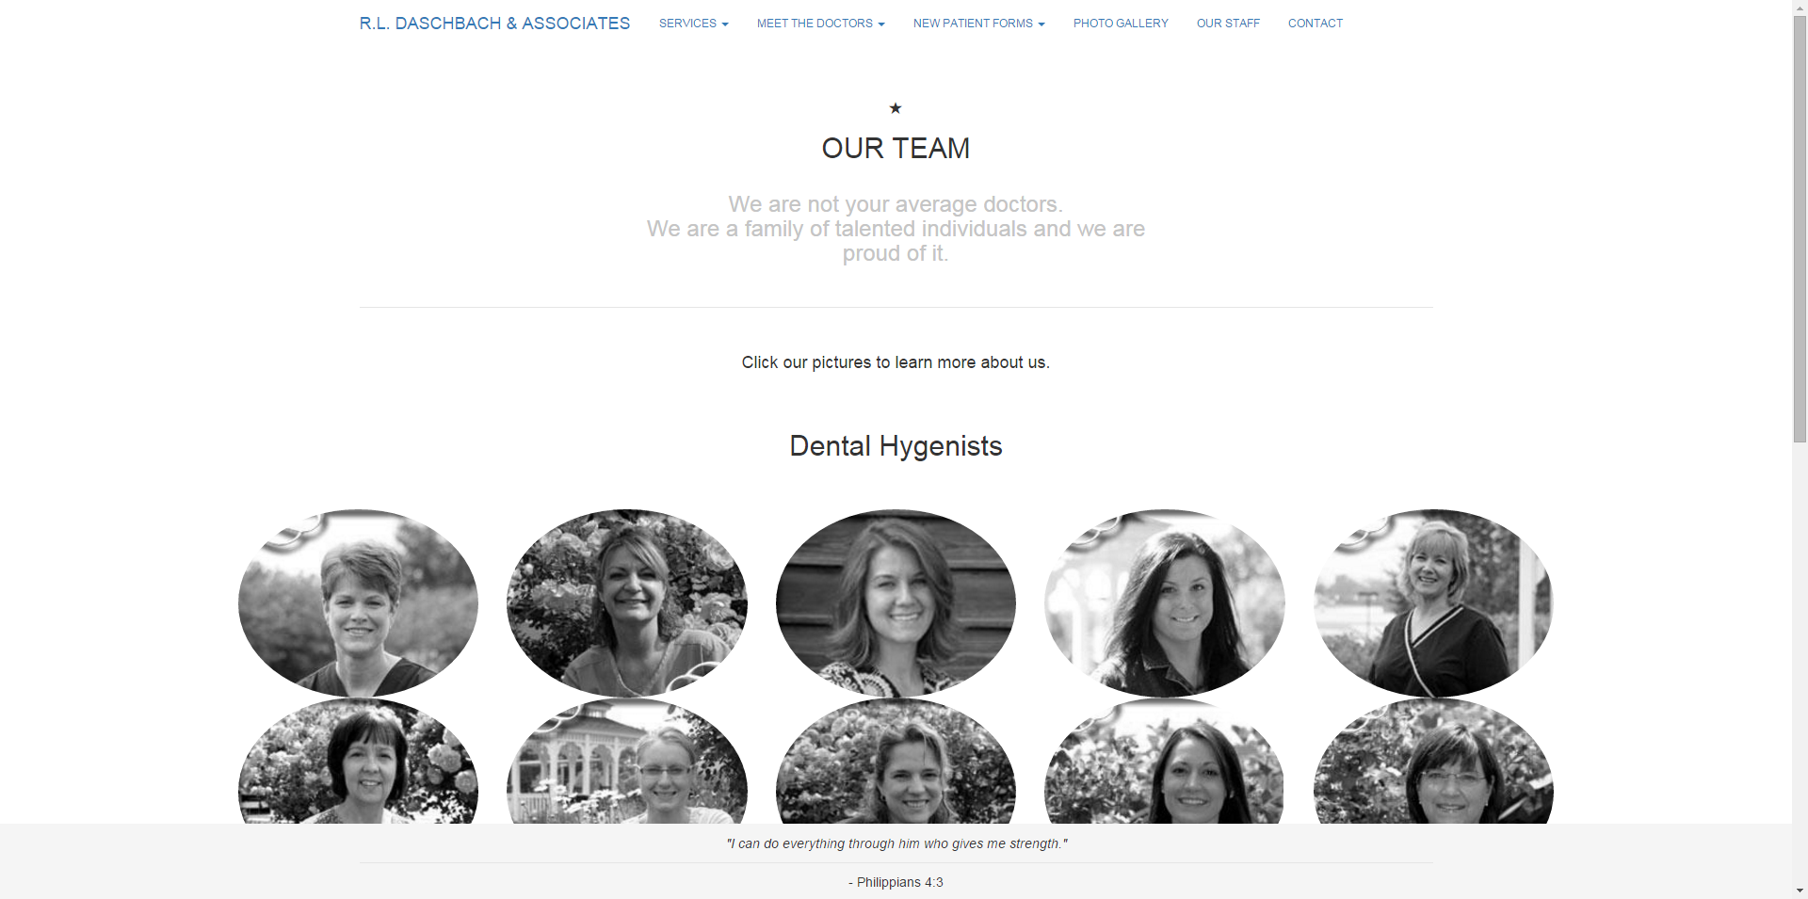

### Responsive View

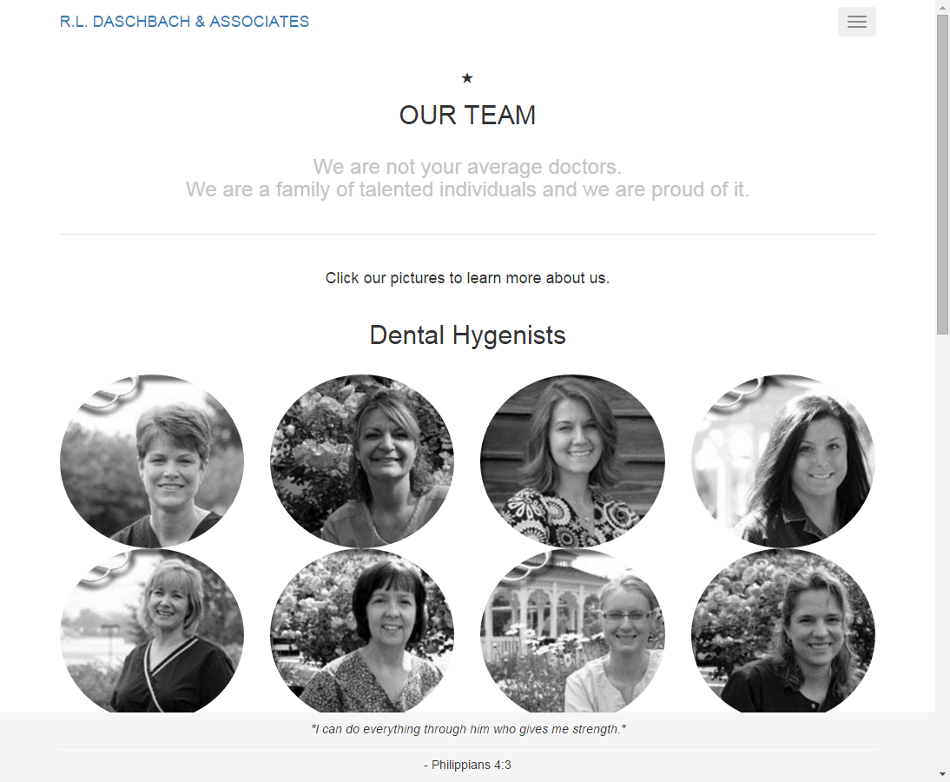

## Contact

The Contact page can be accessed by clicking the ‘Contact’ link in the navigation bar.



* http://daschbachdentistry.gear.host/contact.php

### Business Justification

### Technical Detail

### Desktop View

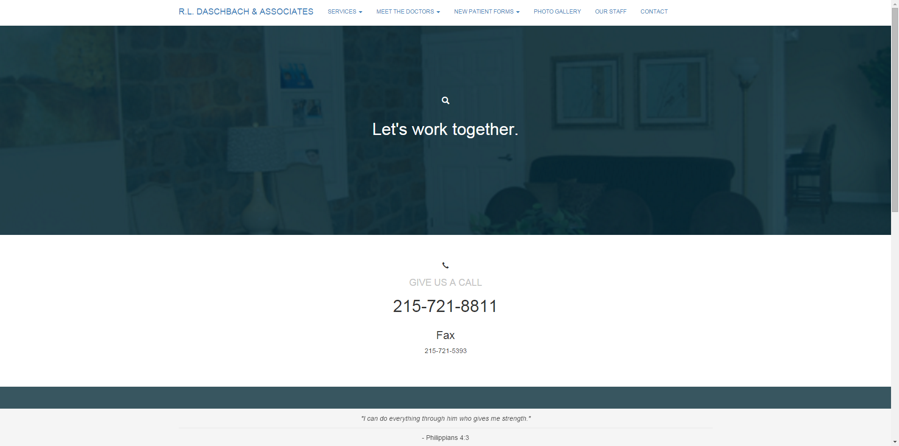

### Responsive View

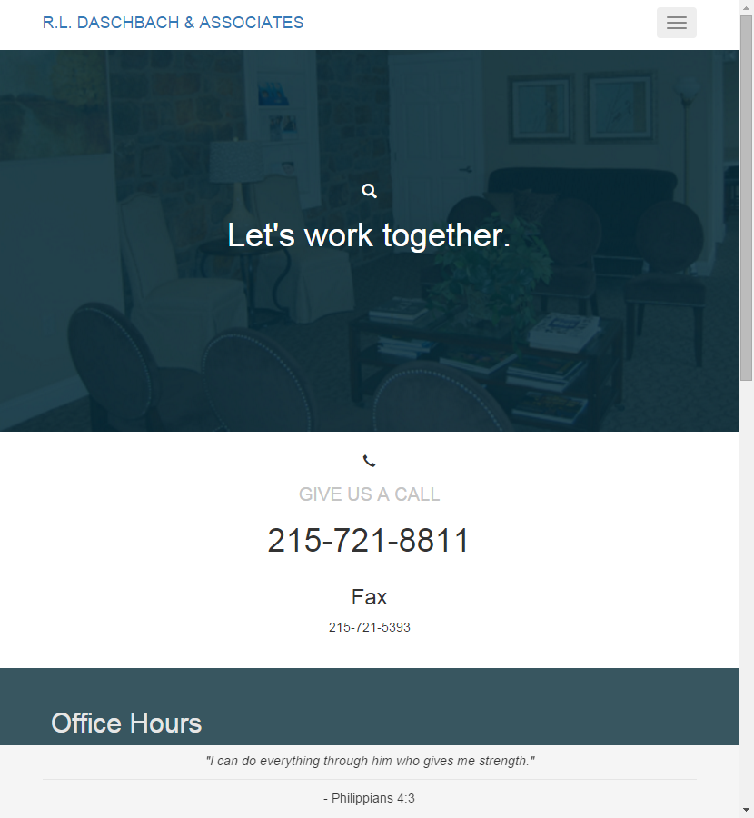

## Careers

**( NOT YET IMPLEMENTED )**

The Careers page can be accessed by clicking the ‘Careers’ link in the navigation bar.

### Business Justification

# Reporting Issues

## Load Times

Each page should load quickly to a user on all devices. Items which may reduce loading are documents, images and videos (if included). Improper website code could also introduce longer load times. When loads take longer than usual, clear the browser cache and reload the page. If the load can be confirmed to take an unusual amount of time on multiple occasions, it should be reported as an issue.